Subscription based online game database

Jason Carpenter and Mitchel Gerber

[JCarpenter11@winona.edu](mailto:JCarpenter11@winona.edu) [MGerber11@winona.edu](mailto:MGerber11@winona.edu) (5/5/1990)

Our project is the back end database for handling the information related to a game database. The database contains game content on which users read and interact with. Admins can add content, users use content, and there are allowances for local instances of data like quests.

The data we have comes from the Blizzard World of Warcraft database. Using a supplied API we pull data on users, quests, guilds, etc. This fills out our quests, guilds, and most of the content data. We hand generate purchase data and personal user data as this is not available to us. Pulling the data from the API we store it in bulk on our end in various tables.

ER:

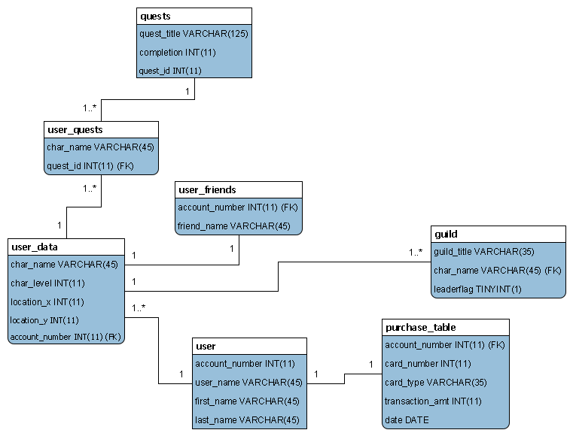

Relational List:

===Database wom

== Table structure for table guild

|------

|Column|Type|Null|Default

|------

|guild_title|varchar(30)|No|

|//**account_number**//|varchar(45)|No|

|leaderflag|tinyint(1)|No|

== Dumping data for table guild

== Table structure for table purchase_table

|------

|Column|Type|Null|Default

|------

|//**account_number**//|int(11)|No|

|card_number|varchar(20)|No|

|card_type|varchar(35)|No|

|first_name|varchar(20)|No|

|last_name|varchar(20)|No|

|date|varchar(20)|No|

== Dumping data for table purchase_table

== Table structure for table quests

|------

|Column|Type|Null|Default

|------

|//**quest_id**//|int(11)|No|

|quest_title|varchar(125)|No|

|quest_reqlvl|int(11)|No|

== Dumping data for table quests

== Table structure for table user

|------

|Column|Type|Null|Default

|------

|//**account_number**//|int(35)|No|

|**user_name**|varchar(45)|Yes|NULL

|first_name|varchar(45)|No|

|last_name|varchar(45)|No|

|password|varchar(45)|No|

== Dumping data for table user

== Table structure for table user_data

|------

|Column|Type|Null|Default

|------

|//**account_number**//|int(11)|No|

|char_level|int(11)|No|

|quests_completed|int(10)|No|0

|image_path|varchar(30)|No|

== Dumping data for table user_data

== Table structure for table user_friends

|------

|Column|Type|Null|Default

|------

|//**id**//|int(11)|No|

|account_number|int(11)|No|

|friend_name|varchar(45)|No|

== Dumping data for table user_friends

== Table structure for table user_quests

|------

|Column|Type|Null|Default

|------

|account_number|int(11)|No|

|quest_id|int(11)|No|

|completion|tinyint(1)|No|0

|//**id**//|int(11)|No|

== Dumping data for table user_quests

OOD:

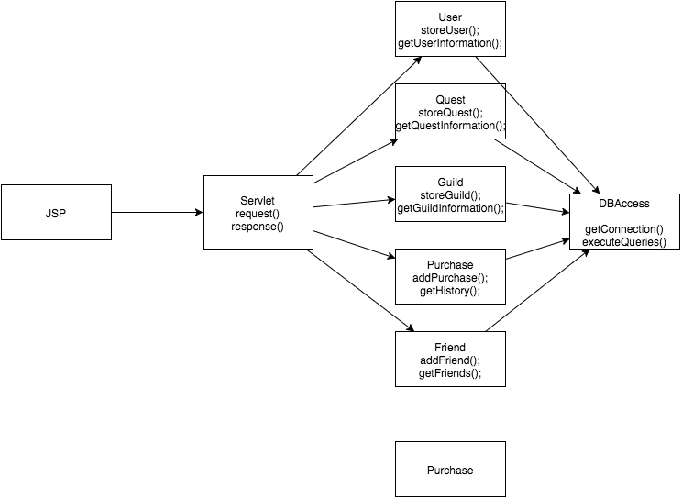

Use Cases: